2011 FISHING REPORTS
10/10/11
This is our latest report via mailchimp newsletter ~ http://t.co/B8t5CSGq
9/23/11
Fishing has been good this week with a lot of bass taken from the boat off the SW side of the Island at the usual rock piles. Cape Cod Eels, live eels, and sluggos are working on the bottom. Albies were here and left... hopefully they will be returning!
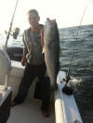 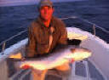 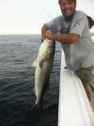 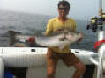
9/21/11
The Block Island Inshore Fishing Tournament was this past weekend and raised over $1200 for the National Children's Cancer Society and BI Lions Club. We thank our sponsors for supporting the event; The Narragansett Inn, Hula Charters, Linesider Charters, Datasport Inc., J&B Tackle, Lemires Custom Plugs, and Edwards Marine.
2011 Block Island Inshore Fishing Tournament results;
Bass / Boat w/bait Peter Vican 44#3oz
Bass / Boat w/artificial Don Smith 38#2oz
Bluefish / Boat Taylor Ingraham 12#15oz
Fluke / Boat Peter Vican 5#7oz
Seabass / Boat John Hunnewell 2#14oz
Beach / Bass Hank Allen 13#10oz
Junior / Blue / Boat Alexis Berlinquilt 11#2oz
Junior / Seabass / Boat Priscilla Hunnewell 2#0oz
9/9/11
Not to much activity due to weather issues... we got out a few days last week and the fishing was good. Good quality fish, not a lot but 6-8 per trip from 20-40#'s. Water has been churned up so you had to drop it on there heads. Fly fishing was very tough... again, water quality a factor. We are out fishing for the next few days so an update will be forthcoming.
8/23/11
The week of big bluefish... 32-34" choppers mauling anything you wanted to throw at them. I actually dug through all my old tackle and found all the plugs not used in years and started thowing them at these things. Had to move up to 30# wire and we still lost a lot of plugs. There are bass mixed in on the topwater action with more bass beneath all the bluefish. Diamond jigs seemed to do the trick to get past the blues, 4oz-6ozs. Fly fishing has been equally fun but cost me two fly rods that snapped above the first eye - lighten up on the drag and enjoy the fight... lesson learned. Fluking is still good along the South Side of the Island in DEEP water on an incoming tide.
SO, the funny story this week. A guy pulls up in front of the shop, window down, and sits there for a full ten minutes staring at the open shop door, engine running. Gordon walks out to see whats up and the man says he wants a box of squid, Gordon says come on in and he'll get it for him, the guy then says "I thought yous was a full service tackle store, why can'ts you bring it to me?". Yep.
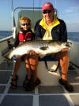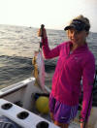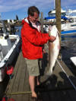
8/15/11
The J&B Tri State Shootout this past week was another success as 80 boats competed for over $440K. All the largest tuna were bigeyes - 258#, 238#, 216#. The largest YFT went 117#'s - very nice for New England waters. The only Block Island boat, the 'Island Lady', lost 3rd place YFT by 1/2 a pound. Offshore reports are still red hot out at Hydro, Veach, & Welkers. Snug Harbor reported big Bluefin taken out at the Mudhole. Inshore fishing has been consistent with the Bass and Bluefish bite mostly SW of the Island. Light tackle or flyfishing - wire up the leaders or you'll lose a lot of gear!
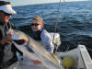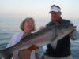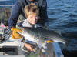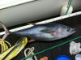
8/7/11
Lots of half beaks are still swimming for their lives with big bass and blues chasing them down which made for great fishing 5 of 7 days this week. We had to add a section of 38# wire to the fly leaders due to the monster blues mixed in with bass. Even added it to the front of the poppers as fish were biting well above the lures. The J&B Tri State Canyon Shootout starts Monday and plenty of great water iFrom Tom's Canyon to Hyrdo. One small BFT was caught this week, the anglers said they saw alot of whales and life close to the Island. Fluking has been very good on the South Side as well as seabassing and is spread out from SE Light to the hooter buoy.
8/2/11
What a cycle this week with red hot fishing then stone cold.... then red hot. It keeps everyone on their toes. Some interesting sightings - a whale in 40ft of water near the Hooter Buoy and White Marlin hooked on a live eel off the SE Light. Lots of half beaks are swimming for their lives with big bass and blues chasing them down. The Canyons were on fire this week with 3 Island boats having 20 tuna days with Yellowfin & the occasional Bigeye. The J&B Tri State Canyon Shootout is next week so more tuna will be caught. Fluking has been very good on the South Side as well as seabassing - more toward SE Light.
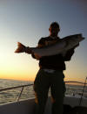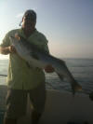 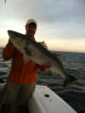 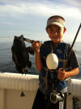
7/24/11
Long week with lots of fishing... and a couple of 'weather days. Most of the LT & flyfishing action was at North Light which took on a Montauk like quality when 20 boats started chasing the blitzes around. The video below was a small taste of the meyham. Fluke fishing has gotten better with 2,3 & 4lb fluke - the occasional 6-8lber as well. Seabass - not so much, no real reports though. The Canyons still have Tuna - one Island boat did 14 YFTs on a day trip!

7/19/11
Blitzes Everyday...
Not a day went by this week when a blitz wasn't found - from SW Ledge to North Light to Whale Rock - bass and blues on top feeding hard. Big flies and big floating plugs made for some fun action and a lot of laughs. Fluking has gotten better off Clayhead and the West Side of the Island - and seabassing is excellent. Yellowfin are out at the Canyons and word is the Bluefin have moved East toward Nantucket / Vineyard. Next weekend is the 6th Annual Block Island Volunteer Fire Department Fishing Tournament. Fishing starts at noon on Friday the 22nd and ends on Sunday the 24th. Cookout and awards at 2pm on Sunday at the firebarn. Don Smith and Peter Vican have won the Tournament each year - is this the year they get upset? Rules and info are at the Block Island Fishworks website and facebook page.
7/9/11
the Past couple days have had really good, sporadic, blitz's at North Light and the South Side. Larger fish have also been caught with 40"+ being the norm. Seabass season opens July 11 and the minimum size is 13", 12 fish a day per angler. Fluking has been a little better now that the dogfish moved out - a lot of shorts though. A 10lber was caught today however. Bluefin are present but spread out. Lucky anglers have been in the right spot at the right time. A 100ber was taken on spinning gear off the Fish Allure on Sunday. Here are some nice fish from the week...
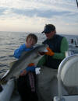 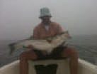 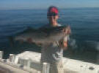 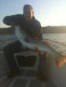 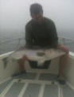
6/24/11
Bass have gotten a little case of lockjaw - they are there but hard to get to eat. White seemed to be the color of choice with a really fast retrieve after you drop it on their head! A Wednesday bluefin run found small pods busting very close to the Island - no hookups trolling, next trip will be casting / trolling smaller stuff which will probably be the ticket. Congratulations to Peter Vican for his new R.I. record striper - 77.4 lbs, 1lb shy of the world record.
6/17/11
Good to poor to good again.... The fish have been spread out pretty good on the West Side and the bait is smaller - 3" sandeels. Mixed bag for size - 16" to 36" fish mixed in together. the rip has been pounded for a week - lots of boats and not a lot of fish. Clayhead also held fish as well as Old harbor Point. Most of the fishing was done from Graces Cove to Dickens Point. Soft plastics and topwater - jiggies and closures on the fly. Congrats to Carl fior his first striper!
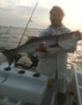 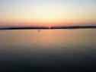 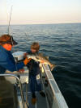
6/6/11
This weekend had the North Light (aka the Rip) turn on with bass on top in the mornings and evenings - plenty of fish (and boats) up to 36".
6/1/11
June is here and it's time for excellent fishing. Lots of schoolie size fish are expected to hit the beaches this week - nightime angling at its best. This past week was a little tougher to find fish due to heavy fog but deeper water on the south side near the Hooter was pretty good. the fish of the week belongs to Campbell Smith who landed this 22# bass on 15# tackle.
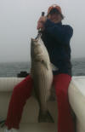
5.22.11
Block Island was blessed with yet another week of great bass fishing. Thick fog made it difficult to spot the birds, but when you found them it was lights out light tackle fishing and even better with the fly rod. The fish are feeding on sandeels and squid and hit the regular array of soft plastics - Cape Cod sandeels, sluggo, pintails, and RonZ's. We should have some video soon of the top-water action as well. Fly rodders did well with sinking lines with clousers and jiggies. Oh - and one fluke hit a sluggo!
Client Sean Smith of Stonefly Guide Service in New Hampshire joined me with his guest Virginia. Virginia, who turned 65 this year, landed over 20 bass on light spinning gear... hands down the youngest 65 yr old I've met.
5.18.11
The first bass of the season were caught last week from the shore and boat. Fish are feeding on sandeels and are spread out but good nights have been had at most of the beaches. Sunday afternoon from the boat started slow but turned on when the fog lifted and you could see the birds working. 7 bass up to 33" made for a good first trip.
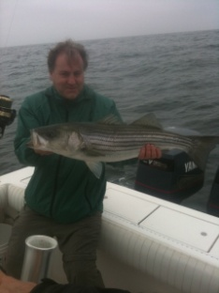 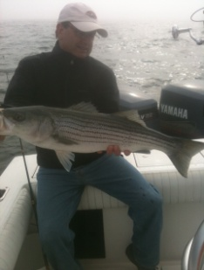
June looks to be shaping up to be really good. If you haven't booked your trip for the summer make sure you give me a call or email and lock in your days. We expect to be looking for BFT's soon - if you want to chase BFT's and be on our trip list, email us at bifishworks@gmail.com

