Get our reports ~ Subscribe to our newsletter

October 28, 2012 | OCTOBER 28, 2012  Unfortunately 'Hurricane Sandy' has called an official end to the boating season. Not that the past month has been anything special for fishing. The shore guys are reporting some action however so this may mean a decent November for surf casting - which would be nice. We made a few successful runs for Albies along the South shores of R.I. but they have all but left now. Seabass have moved to deeper waters but are still around and Cod fishing is started up on wrecks & reefs closer to the island.  On the hunt for a new boat! Anyone know of a 23-25ft center console with 4 stroke power, let me know by texting 401-742-3992 or email bifishworks@gmail.com.  I have all winter and will be picky... but any leads would be helpful.  Venice Offshore Trip.  A few friends and I made a trip to Venice, La. and fished with Capt. Hunter Caballero of Paradise Outfitters. This was our second trip this year and was once again a great time. Venice offers an array of fishing opportunities. Offshore you fish the oil rigs for tuna, amber jack, dorado, & marlin. Inshore targets reds, specks, flounder, cobia, and tarpon (seasonal). You can also go 'bowfishing' at night - its bowhunting for fish (youtube it). I'll try this next time we visit. We stayed with Kingfish Lodges and where very happy with the accommodations. The main lodge can accommodate a group of 14 or so and is very affordable. We'll be planning another trip soon, anyone interested can email me.
Sept. 20, 2012 | 2012 BLOCK ISLAND INSHORE FISHING TOURNEY RESULTS  SHORE  Spin – Blue – 8lb 10oz – Dave Cahill  BOAT / ARTIFICIAL  False Albacore – 5lb 14oz – David Simkins  Blue Fish – 10lb 8oz - John Honeywell  BAIT / BOAT  Bass – 36lb 5oz – Warren Doolittle  Fluke – 6lb 7oz – Don Smith  Scup – 2lb  Sea Bass – 3lbs 8oz – Mike Desmaris  CATCH & RELEASE  8 albies and 1 bluefish - Taylor Ingraham  A special thank to our sponsors; The Narragansett Inn, J&B Tackle, Linesider Charters, George Gilbert, Hula Charters, Datapsort Inc, Hula Charters, Lamires Custom Lures, Edwards Marine, and the Block Island Lions Club.
Sept. 9, 2012 | September 9, 2012  Those with patience and persistence will be rewarded with nice striped bass - these fish have been hard to come by for some but those who found them, found big fish. We managed some 38"-40" fish banging the bottom with jigs and soft plastics. Capt Matt on the Hula Dog wrangled a 50" fish a couple days ago that went 45lbs. But the bluefish are thick and big - 15lbers are regulars on most of the grounds south of the Island. This makes fly fishing a lot of fun but hard to get to the stripers. Then there are the albies (one fish that can make the saltiest fisherman crazy) that have been popping up around the Island with no regard for consistency or predictability - thanks for nothing. The New Harbor channel has had them, East beaches, Old harbor, so good luck! Tis' the season for these fish and everyone is chomping at the bit to chase em! Seabassing is still as good as it's been all summer - make sure you get some in the freezer for the winter. Offshore is still spotty but a couple of Giant BFT's have been taken in the "Mudhole area". Both fish went over 700lbs.
August 25, 2012 | August 25, 2012  It's been a good couple of weeks despite the really warm water close to the Island. There are more 12-15lb bluefish than we've seen in a long time - monsters that are fun to catch but destroy gear. You need to contend with them to catch the bass - most have been found in deeper water at the 1BI Buoy / North light trolling or the Southwest / Southeast grounds. Our best days had 6-8 bass from 32"-42" using 6" plastics (sluggo / ronz / Hurleys / Hogy's) with 1oz jigheads. We were fortunate to have a striper topwater bite 4 mornings in a row on a strong incoming tide at dawn. One of these mornings will be featured on NESN's On the Water TV "Light Tackle Stripers and Flyrod Blues" this season. Seabassing is much better than the Fluke fishing with 18-24" seabass the norm... and they taste good!  The offshore bite was good at the beginning of August during the J&B Offshore Shootout. Tails was off but Atlantis and Hudson were on... now it sounds like it's spotty with guys doing multi overnight trips to find them. And some are going as far as Gilberts - a bit out of range from BI with the center console. You can find mahi and shark closer to the Island however and there was a 760lb Bluefin from the Mudhole this week - despite the warm water.  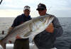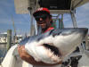
August 2, 2012 | Warm water and bluefish... with big bass down deep. That's the synopsis for the past couple weeks. The bluefish moved in thick this week - all sizes - so eeling can get expensive. We tried using heavy jigs with plastics and it seemed to work pretty good. 1-2oz jigheads or heavy bucktails got down quick, and if you hugged the bottom you usually got bass. Seabass has been very good - 20" fish are regular catches in deeper rock piles. Black fish opened yesterday and there have been loads of keeper size fish around the island. Fly fishing is best early in the morning - early - the bite is usually an hour then it's bluefish time. The silver lining with this is that a 32" bluefish on a fly rod is fun stuff! So there is plenty of fun to be had.  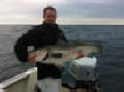 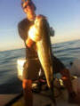  Dave Released this 35lber Jaixen caught this 33 lber for the BIVFD Tourney
July 21, 2012 | Earlier in the week the water warmed up to a surface temp of 72 - so the bass fishing moved to deeper waters from the boat and the East side of the Island from the beach. Most of the charter boats are reporting very good fishing - mostly on eels - but we had pretty even success on soft plastics. None of the fish are on one particular spot - you have to move around looking for them and stay on top of them. The past couple days of East wind cooled things right off to 66 degree surface temp and the fish moved back into the shallows making for easier access for the fly fishers. Seabass and fluke fishing is really good right now - big fluke on the South side in deeper water (60+ft) and seabass are not to hard to find with em. We went looking for Bluefin last weekend and trolled up a small one at Tuna Ridge. Saw a few sharks but not a lot of life otherwise - water was 74.  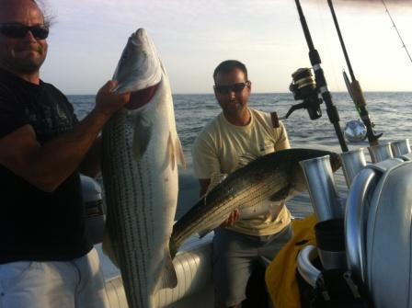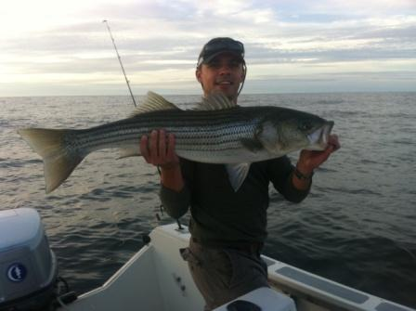
July 12, 2012 | Hot/Cold, good/bad - the past couple weeks have been really good or really poor depending on the day. Really poor meaning you had to grind it out to find fish wanting to eat something - even eels. Really good meaning the fish were big and and hungry eating everything. Most of the bass have occupied the deeper holes requiring any presentation to be close to the bottom. Smaller soft plastics seem to work better than the bigger stuff - you just need a 1oz+ jig head. Early mornings have had fish in the shallows hitting topwater plugs and flies - this seems to peeter off with the suns position. Sea bass are almost always hungry and the fishing has been pretty consistent for them. Lucanus jigs, diamond jigs, and small plastics are working well on the bottom - and of course fresh squid or clams. Tuna reports trickle in here and there and the summary is GO LOOKING... those that have taken the initiative and went for a look around have had seen and hooked fish. There are schools of halfbeaks dispersed throughout the southern waters of Block Island so the bait is here - go look for the fish.  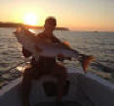 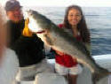  Seans 40in fish on the 3rd Alyssa's first striper on the 9th  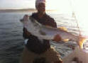 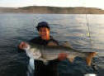  Joe's nice on on the 12th His son Cody had a nice one too.
6/25/12 | June 25, 2012  Great week for bass fishing as the bluefish thinned out a bit and the bass where hungry on this past new moon. We had fish in the 30lb range all week on the early morning bite using Soft baits (CC sandeels/sluggo/Hogy). The 41lb 4oz bass below fell for a 6" rainbow trout sluggo - white bass assassins worked too. The bluefish caught were big and spit out big squid - which might explain the commercial trawlers in the area. The sea bass bite is also good and on the same grounds we were fishing for stripers. Black Sea Bass is one of the best tasting fish & I encourage keeping these over the stripers, they are way better than striped bass on the table!  A disappointing offshore run to the Tails on Sunday had us a day late and a few dollars short with nothing to show - such is the game - it was disconcerting to see such a lack of life out there. A few boats did catch a few YFT's in the 40-60lb range Saturday. The J&B Sharkfest was this weekend and the crew from the Bottom Line cleaned up with the 966.5lb mako beast!  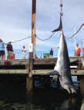 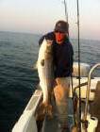 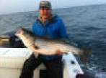  Catch & Release Facebook Page  Post your released fish on the new facebook page called 'Fisherman's Wall of Mercy' - This is for catch and release photo's only, great page to show off your fish you let go to catch another day!  Tournament News  The PBR Tourney ends the 7th. This past weekend had a few more changes to the leader board.  BOAT:  06/24/2012 R. Kroha 55 lb. 1.6 oz.  06/18/2012 D. Smith 52 lb. 6.4 oz.  06/10/2012 T. Hanna 42 lb. 0 oz.  SHORE:  06/24/2012 J. Hanecak 50 lb. 0 oz.  06/19/2012 G. Soldati 28 lb. 9.6 oz.  JUNIOR BOAT:  06/22/2012 D. Yeaw 50 lb. 0 oz.  The Block Island Inshore Fishing Tournament will become a catch and release tourney (bass / blues / albies / bonito) - details are still being developed, but it will most likely entail points and total lengths. Stay tuned and feel free to send along any thoughts.  LIGHT TACKLE & FLY FISHING TRIPS  Our Fly and Light Tackle trips on the 21' Aquasport are $375 for 4 hours for up to 3 people. Larger parties, families, and offshore trips are accommodated on the 26' regulator and start at $500 for 4 hours. For reservations call 401-742-3992 - email bifishworks@gmail.com  SHARK TRIPS & TROPHY BASS TRIPS - NIGHT EELING  There are a limited number shark trips and night time eel trips for TROPHY STRIPERS - call 401-742-3992 for prices availability or email bifishworks@gmail.com
6/13/12 | Bluefish, Bluefish, Bluefish - there are alot of bluefish around the Island. But there are also a few big bass! Beach fishing has been pretty good with a couple guys weighing in 31 and 36 lb fish. Fly rodders also have been doing pretty good off the west side with sandeel flies - mostly 24-30" fish. Historically the weeks on both sides of Fathers Day are excellent from the west beaches. Boat fishing has been a bit frustrating if you don't like bluefish - but here are bigger bass around. Peter Vican weighed in a 41.8lber, Timm Hannah topped him with a 42lber (guided by Capt. Matt King), and Capt Bill Browns customer landed a 44lb 6ozer. On this mornings trip we got into a 42" inch fish that measured out to about 34lbs and was released successfully as was Jake and Dianes 37" & 35" bass from Monday.  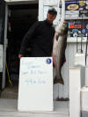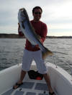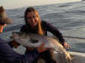
6/10/12 | Great start to the 2012 season  Mother Nature has not been nice the past week, putting all boat fisherman on a 'time out' with rain and wind. The beach fishing has continued to be very good, unlike 2011, and some nice fish are being caught (and lost). Looks like the large bombers (17A's) and Sebile Magic Swimmers are the right choice from the beach. Monster squid are in New Harbor as well - you can get a nice bucket full within an hour most nights. Before the weather moved in there were bass feeding on sandeels on the West side and they were finicky - a teaser fly above a sluggo and jighead got em to bite however.  No real report from offshore other than a 200+lb mako taken by a local boat south of the Island. Saturday will be the first 'go look' trip for BFT's so hopefully we'll have a good report.  Check out a new facebook page called 'Fisherman's Wall of Mercy' - This is for catch and release photo's only, great page to show off your fish you let go to catch another day!
5/27/12 | Great start to the 2012 season  The fishing has been pretty good this week with a solid three good days last weekend - fish on top feeding on sand eels along the west side was the scene. This continued through the week and into the Memorial Day weekend when weather permitted. Picky fish and pea soup fog did make it tricky at times. Soft plastics on light or no jig head were the trick. Fly fishing found epoxy sand eels patterns in black or olive over white producing the best. Small squid patterns also worked. The couple fish kept for the grill had sand eels and baby squid in their bellies. Speaking of squid - its good squidding in the harbor around the lights on the docks. Local angler Ed McGovern landed a 40+ pound fish from the beach on Saturday night - which beach?... ask him! Nonetheless the beach fishing is good at night.
4/26/2012 | Schoolie to keeper size bass have been caught off the beach the past weekend. Tinker mackerel are also being caught in the harbors. Early start to the season!
4/15/12 | April update via our mailchimp newsletter ~ Migrating Bass and the 2012 Tournament Schedule
3/9/12 | This is a winter update via our Mailchimp newsletter ~ http://t.co/SkVHOIst
Visit our shop on Ocean Avenue, New Harbor, Block Island

