2010 Fishing Reports;
10/26/20: Went on an impromptu trip yesterday morning based on credible report that there were some fish around... headed out on the 31' Bahama, went due south with no real plan other than to 'go look'. at about 7:30 Capt. Joe spotted a couple 'splashes' so we stopped to see what happened when 3 BFT's went airborn! We grabbed the spinning gear and started casting. Another 5 minutes and a pod of dolphin surfaced and surrounded us, then some bait scattered 20 yards away and we launched the 10" RonZ tuna rigs in that direction. Joe hooked up something, and not seeing any busting tuna we thought big bluefish... the fish was headed right to the boat. However once it realized it was hooked the blistering run began and it peeled of half a spool of 80 lb braid- the fight began and we knew we had a tuna. We had color after 10 minutes... then it took another loooong run. After the fish kicked Joe's butt for another 25 minutes he had it boat side and we saw it was a respectable 50+" fish - I hit it with the gaff and game over. At 54" it weighed in at 85lbs - a lot of fat on this fish. It's belly was packed full of 10" halfbeaks. Water temp 60 degrees. Back at the dock at 9:30 - what's better than that. Block Island in the Fall!
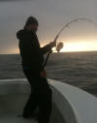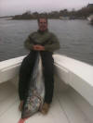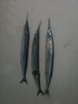
10/17/10: The full on October run hasn't really got going here... at least not like last year when 30-40 fish nights were weekly events. But bass are being picked here and there, especially at night, on needlefish and soft stuff. Hula Dog phoned in a midday report that the SW corner was going off - and it was with monster bluefish and scattered bass feeding on big sandeels. These blues were 36"+ and simply were alot of fun to catch. Seabass close the 11th so come November 1st we'll start that again. No real news regarding tuna near shore - YFT's are still being caught from the Tails to the Hudson. Giants usually show up around now and the bluefish/sandeels this week looked promising.
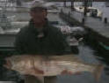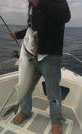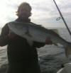
10/2/10: SO there are Bass being picked here and there from the beach and boat. OH Jetties held fish, North Light, and the inner ponds. Seabassing is open for a bit longer and has been great. For those who troll use parachute jigs. Pink and white soft plastics on LT and big needlefish from the surf. Fly fishing? Tell the wind to stop, pr at least dip below 15 knots...
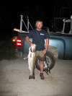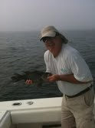
9/21/10: Block Island Inshore Fishing Tournament 2010 Results
Great weather this past weekend and a turnout of nearly 40 anglers for the tournament. Over $1100 was raised for the National Children Cancer Society and Island youth charities. The fishing was slow... 9 fish weighed in, 7 winners. Fun nonetheless. We will open seabass as a category next year and expand the junior divisions.
Bass Boat w Bait - Don Smith 33#4oz
Bass Boat Plugs - Bob Boermeester 19# 7oz
Blue Boat Troll - Dave Simkins 11#4oz
Blue Boat Plugs - Glenn Hastie 11#14oz
Blue Boat Jr Div- Ian Fister 10# 5oz
Bonito Boat - Bob Boermeester 6#11oz
Fluke - Don Smith 3# 7oz
Trifecta - Bob Boermeester with winning fish above and a blue at 10#8oz
Thank you to all our sponsors; Gilbert & Jones Co., Peter Vican, Hula Charters, Lemires Plugworks, Linesider inc., Wavespin Reels, Sebile Lures, Block Island Boat Basin, The Beachead Restaurant, The Oar, Paynes Dock, and the Block Island Lions Club.
9/15/10: Albies in New Harbor, Bass in Old Harbor. Made a fly fishing trip to Montauk over the weekend and it was kooky with great fishing. Grand slams became easier just ten miles from our home waters. A lot of boat traffic and characters (maybe that's why the tried to make a TV show about it) and short tempers too... it was all fun nonetheless.
The B.I. Inshore Fishing Tournament, hosted by the Lions Club starts Friday the 17th at 6pm and runs to Sunday the 19th at noon. The tourney benefits the National Childrens Cancer Society as well as an Island Charity. Hope to see you!
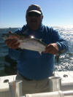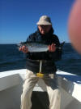
8/26/10: I'll cut to the chase... fishing has been slow - even for the legendary Block Island. Although one 47#er was weighed in caught by Don Smith - at night. In fact all fish being caught are in low light... so start at dusk and fish till sunrise. Earl may spark a good chew tomorrow - we will see. My best catch of the week was yesterday 8/31/10, when the sun was high at 12:59pm, 19.5", 6#14oz's - our new baby boy Miles Dugan Willi. Mom and Miles are great!
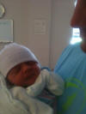
8/19-8/25: Ok momma nature... enough with the wind already... it's been blowing for 4 days now and we want to go fishing. And when its blowing 20-35 from the N, NE, & E we can't go by boat, and its tough on the beach too. before the wind and rain kicked up there were still some bonito around hitting small ronz's, metal, and the ever-loving jumping minnow. On the fly we went with the Skok tied mushy... small and skinny. From the beach guys had bass in Cow Cove and SW Pt. on eels. Needlefish are taking fish as well - green/yellow and Black. Offshore reports before the weather set in had most fish on the chunk... who knows now. September is almost upon us and that means the B.I. Inshore Fishing Tournament starting Friday Sept. 17 and ending Sunday the 19th. Info is on the website. Pre register by shooting us an email if you can't make it by 6pm Friday. Fishing is limited to 3 miles around Block Island. Any questions give us a call!
8/9-8/18: Bass are here but very tough... guys with eels are having a bit of a rough time getting them to eat, topwater has all but died the past 4 days, the full moon won't help either. Plenty of scup/seabass/fluke... Bonito are here as well - east and West sides, and the word is out with a lot of boats running and gunning. Patience is the name of the bonito game provided there are not to may knuckleheads pushing the fish down... pick a spot and wait - you'll be surprised how many you can get. Three on the fly yesterday and two with a jumping minnow. White bunnies or 2-3" baitfish patterns. Crystal minnow and the assortment of metal/tin has worked as well.
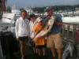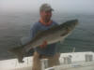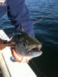
7/26-8/8: Went to the Gully last Friday with no BFT's to be found, hit the tails Saturday and had the first YFT hit right at sunrise on the flats, we trolled to the head of the canyon - counted 53 boats... trolled around there for a few hours and watched manta's doing back flips all morning. Headed back to the flats and picked up another YFT - both about 60#'s. Back at the dock at 2pm. The Tri State Tourny has a great turnout with 90 boats. A 158 Bigeye took top honors, local boat 'Island Lady' and Joe Noel's crew took top albacore prize money. Fish were taken from Hydrographers to the Tails. Bass and fluke are pretty good around the Island. The coldwater incoming tide was perfect on the south side with most bass taken on LT measuring 34-38"s. Clayhead, SW and SE fluking has been reported to be good numbers and ratio of keepers to shorts.
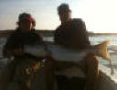
7/23 - 7/25: Bass have started back up with good reports spanning all sides of the Island. Fished a 32 Regulator for Saturdays sunrise and Sam Z. landed another BFT at the same place, this one went nearly 90# - 15 minute fight, wired, gaffed, iced, at dock and cleaned by 10:30am. Then went fluking that afternoon but was not so lucky - alot of 18" fish. Getting pumped up for J&B's tri-state shootout next week - 90 boats fishing it!
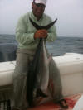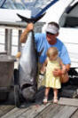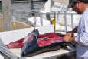
7/12 - 7/22: Big bass earlier in the week, 40"-44", not on great numbers though, The bait has seemed to dissipate lately - still some sand eels around and smaller bass on top. Had our first grand slam of the season on the boat, bonito, 42" bass, and big blues on the South Side. Had another bonito off Great Pt - sea foam green RonZ and bubblegum sluggo. Found no YFT's on last weeks trip to Atlantis - but a bunch of mahi was brought home for the grill - whales, birds, porpoise, bait.... all the signs, marked some fish but couldn't get them to eat. Had some 3-4 lb seabass and some 25" fluke from the Clayhead (North) and Hooter buoy areas. One report from Montauk had BFT's 20 miles due south of B.I. but the run Wednesday was a bust. They are still around so time to chase them down.
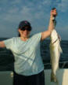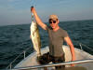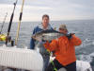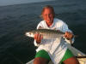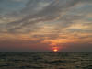
7/5 - 7/11: Spent most of the week striper fishing with one tuna trip. Bass are on top on the south side hitting Cape Cod Sand Eels and RonZ's... getting a bit finicky so using monster hooks and dead sticking worked, the Jumping Minnow was hot as well. The BFT bite slowed a bit but some reports were positive the past couple days. Maybe headed offshore to look for YFT, let you know how it goes...
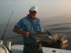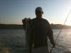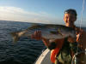
6/30-7/4: So those BFT's were close. Close enough so that it only took us 45 minutes till lines in on the 'Fish-a-lure', a 31' Bahama, fresh from her trip up from Grand Isle, LA. to fish New England for the season. With the Island in sight and no boats around we went 5 for 6 on the troll with a personal best a 59", 160#er... The next day the Fish-a-Lure went 10 for 11 on footballs. Yesterday was 5-6 trolling on the 26' regulator, 40# class fish, with monster blues mauling everything as well. Today was one for one on a short trip. Whales, sand eels, birds, etc... covered the area from the fairway buoy and due west. Lots of boats the past two days. Went out for some fluke and seabass yesterday - nicest flatfish was 22", seabass was a 4#er. Looks like a busy week ahead. HAPPY 4TH......
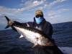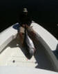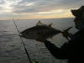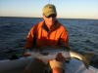
6/22-6/29: So it slowed some with picky fish tormenting alot of fly and spin guys, but it only lasted a few days. Black Rock was on fire this morning for an hour. 24" to 40" fish on the rnbw and albino rubber - a couple on topwater as well. Reports were also good for the SE corner but I never made it over there. There are some big fish around - had one that went 44" at the boulders before the 3 mile line at SW Ledge. The picture of the BFT below - went over 125#, don't ask me where - I find out on tomorrows trip. click on the pics for a better view...
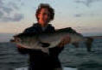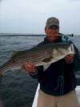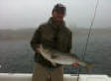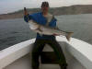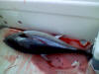
6/16 - 6/21: The rip has been consistent, but got crowded quick. Fish feeding on sandeels from 2"-4". RonZ & sluggos worked well. Flatwings, epoxy sandeels, and striper dragons were flies of choice. Alot of fish have been in deeper water off SW bouy... had some hit topwater and jigged some up from 50' - sinking lines and soft retrieves worked on the fly.
6/15/10: It slowed for a couple days but things are back to 'normal'. Beach guys are dooing very well at the cut and Charleston Beach. While leaving for a trip the other morning I counted 13 anglers... all fly fishing (yes!). Dusk and early a.m. are the ticket. Tried to jump a school on the flats in New Harbor but was a little rusty on the stealth in 26' Reg. Squidding has been pretty good as well (yes squidding) - under the lights at the marina's. Seals are still at N. Light - must be to crowded at Monomoy.
6/7/10: Hey, the fishing has been stupid good... whether from the boat or beach,
fish have been everywhere. When customers are having 30 fish in the
high teens in a couple hours - it's good. Had a couple keeper fluke
Friday then the dogfish started. Bait everywhere - seals are still
around as well and whaled where spotted ...at the rip last week
6/1/10: Charleston Beach has started holding fish for the surf casters. A dredge working the channel this week has stirred things up and guys have picked fish up on the fastest part of the tides. Lots of sand eels here and squid are in the pond. North light looked like a scene from the canyons this week with whales being spotted, petrels, 'tuna birds', etc... no tuna - there were bass. Picked up two nice fluke and seabass yesterday off the west side near Graces Cove.

5/24/10: South side in deep water - huge schools of sandeels. Had to go deep for the couple keeper bass, 30" blues over the top of them. Sluggo city.
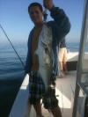Mikes 10lb blue

5/23/10: 1-2 miles on the SE side, bass rolling on sandeels with mixed blues. 4" sandeel patterns on the fly rod. Outgoing tide.
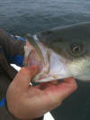First on the fly for 2010

5/21/10 : didn't leave the dock till 6 and missed the first hour of the bite. SW corner held bass and was spread out up to graces cove. Bass & Blues

5/20/10 - a.m. bite was on the east and s.w. under birds - new arrivals were gorging on sand eels. 12 fish in a couple hours 24"-36"'s... throwing the plastics. Same thing yesterday evening - fish were a little picky - some were jumping clear out of the water - Gannets were diving as well, thought they would ...be gone - we also saw seals at N Light in the a.m.?? Headed out again in 15min!

