2009 Block Island Fishing Reports
Sept. 22, 2009
The Block Island Inshore Fishing Tournament was blessed with some good weather on Saturday and Sunday. There were a few good fish caught and fun had by all. On behalf of the Block Island Lions Club I would like to express our sincere appreciation to all of the participants and sponsors of the Block Island Inshore Fishing Tournament held this past weekend. The Beachead, John Kisseberth, Carol Payne, and the Block Island Boat Basin provided all the food, Linsesider Inc and J&B tackle donated gift certificates, Wave Spin Reels, AH Edwards Marine, Twin Maples, Lemire's Plugworks, B.I. Custom Plugs, and B.I. Fishworks provided additional prizes, Paynes Dock hosted the cookout, and Peter Vican once again donated a great variety of sports memorabilia for the raffle. All in all we raised over $700 for the National Childrens Cancer Society and $700 for the Scholarship fund for BI School students.
RESULTS;
Bass beach/spin Dave Morse 15.12lbs
Bass boat/bait Sam Orr 42.6lbs
Bass Beach/spin Matt Tomich 12.84lbs
Blue Boat/Spin Don Smith 11.38lbs
Albie Beach/Spin Ted Loughman 11.06lbs
Albie Boat Spin Matt Tomich 7.36lbs
TriFecta Bass/Blue/Bonito Sam Orr

Sept 14, 2009
Well Labor Day was a bit banana's with a 20+ knot breeze blowing right on schedule out of the Northeast making it hard for some of the small boats to get out fishing... After the weekend mayhem we hit the South side in the mornings to find it slow going - small bass and blues mostly - but grand slams were tallied every trip with Albies, Blues, Bass, Sea Bass, and more monster scup (15"-17" fish). After three days of more Northeast wind this past weekend I was hoping it would turn the fishing on again - but no... Searched S.E. to S.W. with only small fish, but fortunately still managed a grand slam each day. Ventured North and found monster blues in the rip - 30" fish - mixed with bonito and small bass - hit Clayhead for the only keeper bass in a week.
Looks like the weather will be nice this weekend for the annual Block Island Inshore Fishing Tournament hosted by the Block Island Lions Club. Registration is $40 and all proceeds benefit Island Charities and the National Childrens Cancer Society. Anyone can register at Block Island Fishworks or Twin Maples on Friday by 6pm. If your arriving late email us or call the shop at 401-466-5392. All weigh ins will be at Block Island Fishworks. The awards and cookout will be at Paynes Dock at 1pm Sunday. See you there!
Sept. 3, 2009
It's sure to be a busy weekend on the water so we plan on beating the crowds and fishing early... Bonito and Albies are around on the East and South sides. Loads of bluefish on the East as well. Vaille had the three B's today - blues, bass, and bones - Yozuri's, topwaters, and plastics all worked, used Skoks nasty needle flies to get some as well. Seabassing is good right now with legal size Fluke still a little tough. Monster scup around - had one nearly 4lbs... like a hubcap. Word is the mudhole has tuna - it's sure to be a parking lot this weekend.
A reminder to everyone that the Block Island Inshore Fishing Tourney is September 18-20th and is presented by the Block island Lions Club - info is available on our tourney page - proceeds benefits the National Childrens Cancer Society and Island Charities - hope to see everyone again.
August 29, 2009
A pretty good week with the rip turning back on with alot of small bass. The south side still has bigger bass moving fast through various areas, bites lasting 30min - 1hr then shut off so we moved around a bit. No BFTs seen south except for some sub legals released. Rainstorm Danny was enough to scare everyone away from the Island, like Bill did last week - we were hoping for another epic pre storm fishing bite which didn't materialize, but it was good nonetheless. Here are some pics from last week and and buddys trip to the Hudson two weeks ago...
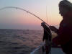 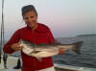Mada's Bass at the rip
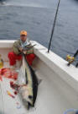 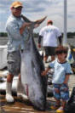 Kevin's awesome bigeye from the Hudson
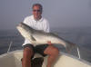 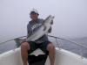 Dave & Duncan on the pre storm epic morning...
August 22, 2009
We has some of the best light tackle fishing of the summer this morning at Black Rock... big swell and BIG fish, and the only other two boats were good friends - and we had the whole south side - amazing morning! David and Duncan Fox landed several fish over 40" using nothing more than a 6" plastic in rainbow. The south side seemed to slow a bit the past couple weeks and was heavily fished. We managed to find some smaller pockets to work away from the crowd and had lots of success. Sinking line in deeper water was the way to go for this week - sand eel flies were all that was used. Bonito were finally caught in the New Harbor Channel. Those willing to camp out for the day were able to get into a good blitz - patience pays off. The BFT are reported to be close as well - we ventured between the fairway and Acid barge and had one small one and lots of life, whales, porpoise, and birds - had a few big marks on the finder as well.
August 11, 2009
It's 90 degrees on the mainland... and no wind.... but a cool 70 degrees and a light southerly cooling us down here on Block Island. And yes the fishing is still happening, a bit slower but it's good nonetheless. Katie and Mark (pics below) had a slower than average morning. Katie manages a 40"+ bass and another keeper. Mark managed a 7" seabass... Black Rock has been pounded the past few days with lots of boats on the usual spots. Other grounds and holes provided an escape and plenty of fish. Dories, Graces, and SW have held fish everyday but are spread out over the entire area. Long drifts and patience will find you some fish. The sea bass must be in since the fish pots are now here. The J&B Tri State Shootout was a huge success with a lot of fish caught. A Big Eye took top honors. Two Blue Marlin over 550#'s were caught as well as a 375# swordfish. BFT's are rumored to be close by... waiting for the opportunity to go look for them.
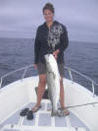 Katies fish 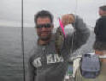 Marks fish...
August 2, 2009
A very good couple of weeks of fishing again with a slight slow down in the pasty two days. The East side, Clayhead to SE Pt. has had fish with the boats using umbrellas or eels doing well with some fish in the 40# club. The West side and Black Rock / Vail / Lewis / Barlows has had plenty of fish up until Friday when things slowed a bit. Big flatwings have worked for fly rodders - olive grizzly over white, and all white gurglers on top. Bluefish have moved in as well with more blues than bass for some. Friends went to Cox's for cod and had more dogs than anything else. The J&B tuna tourney is the next three days so the offshore grounds will see at least 75 boats fishing. Water temps are still below 70 degrees inshore.
July 20, 2009
Bigger fish have moved with several 30#-40# fish taken over the weekend. Peter Vican won the 5th BIVFD fishing tourney with a 40#er - again! Peter and Don put in their time fishing and share their information and techniques with anyone so anyone whining about how these guys always win... shut up and fish - that's what these guys do - just FISH. The Tourney also saw some big fluke 6 and 7 lbers - finally some keepers! The entire West side has been alive with bass on top feeding on the plethora of sand eels... so fly rodders are having luck with sand eel patterns that stand out from the live ones. BIG (6") deceivers in white and grey over white nailed bass at Black Rock without the need for a teaser plug. Monster blues where also found on the outside of the Black Rock buoy. 31"-36" blues mowed down everything and were an excellent time on light spinning gear. This morning had bass up to 42" on 6" RonZ and sluggo's. Ventured offshore last week for the first trip of 09 on the Island Lady. The Alvin Canyon had YFT and Ablies with some big Mahi for us... had 2 YFT, 1 albie, and 4 Mahi - and just as many knock downs and dropped fish! We were like a bunch of rookies out for a boat ride - now that we have the kinks worked out the next run should be better. Anyone sweating it out on the mainland, remember it's always 10-15 degrees cooler on Block Island.
July 9th, 2009
Wow... another three days of great action. Fish were on top under birds just about everywhere from Graces to Black Rock in localized pockets rolling on sandeels about 5" long. The fish were not easy biters but modifying our usual soft rig was the trick. Worm hooks in DOA's, Zoom Flukes, Sluggo's, Hogy's etc... worked slow and close to the surface was consistently working. But you had to drop in on their heads when they came up - at least get it in the vicinity! I found a 1/16 weighted Gamakastu 5/0 monster worm hook to be best. Fly rodders used typical sandeel patterns but had to again hit em on the head. If that didn't work we went right to the bottom and had pretty good success. Outside the Black Rock buoy and SW buoys were where they were with smaller grouping close to shore but no birds over them. Fish were 28-38"s...
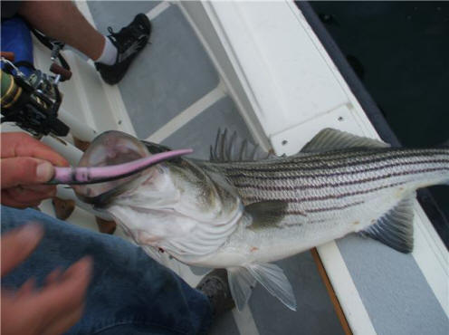
July 4th, 2009
Great fishing for a solid week. Even with the rain and T storms early in the week we were able to fish SW and Black Rock with great success on the fly and light tackle. Smaller Sluggos and Ronz were the ticket for what could have been finicky fish which were on top but not liking the topwater. The fish were rolling on sandeels at SW Pt - but only in a tight pocket and would have been missed if it were not for some birds working them. Big white deceivers worked for fly rodders as did the epoxy sand eels is lighter shades. Squid flies are hot right now as well - 1"-2". Hit the beach hard with hardcore fish finatic Lou Eagle. In his 60's, Lou can fish a 11' fly rod from the beach for hours without a break... Cooneymus, Charleston, Mansion, Scotch, Cormorant, and the Channel held fish... Dories and Graces did not. 4 nights of this and my shoulder is mush... big dark patterns, like snake flies, worked everywhere.
June 24, 2009
This has probably been the worst weather on record for June but the fishing has been great nonetheless. Steve Colton and his brave crew hit the beaches on Fathers Day night fly fishing and reported a spectacular time despite the insane wind. A couple of days of northerly wind and we finally got out on the South Side and did OK yesterday and fantastic today. Dogfish are still everywhere making a mess of things for the flukers... who after sifting through the dogfish are still finding it hard to find keepers. The 1st Block Island Shark Tourney is this weekend hosted by J&B Tackle - hope to have some good pictures.
June 17, 2009
The fishing has been really good at dusk and into the night. The Rip has been red hot on the moving tide, sometimes top water and sometimes mid water - sluggos (anything like them) and the jumpin minnow are choice lures for light tackle guys. Brian, Marianne, and Tony came fishing with us again and had a spectacular sunset trip at the rip with 30 fish in an hour. Squid flies, white deceivers, and sandeels are working on the fly. Joe and Suzanne enjoyed a sunny morning chasing some bass at the Rip and then at SW Pt. The fish were a bit finicky but getting the fly into the middle of the pack seemed to prompt the strikes. Charleston Beach has maintained it's reputation as the place to be for the first to weeks of June for the surf casters and the New Harbor channel is freshly dredged and holding fish. Not much happening at Black Rock yet....
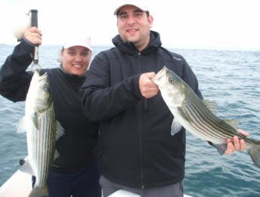
Marianne and Brian 6.13.09
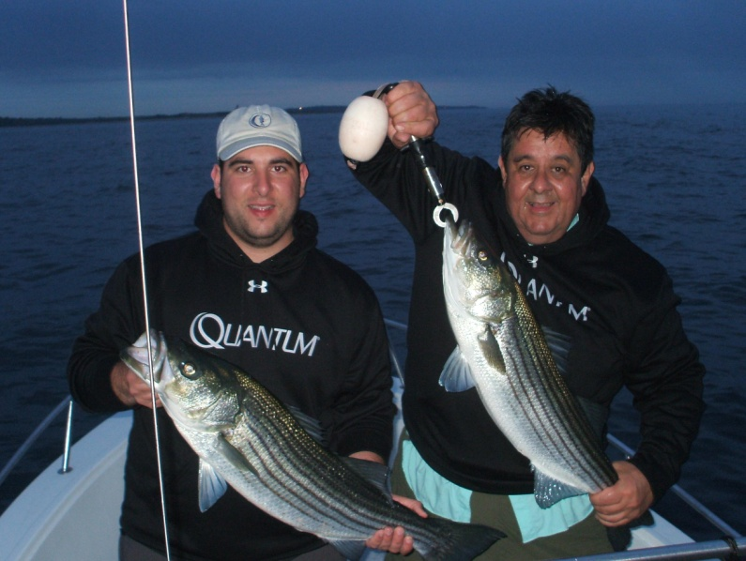
Brain and Tony 6.13.09
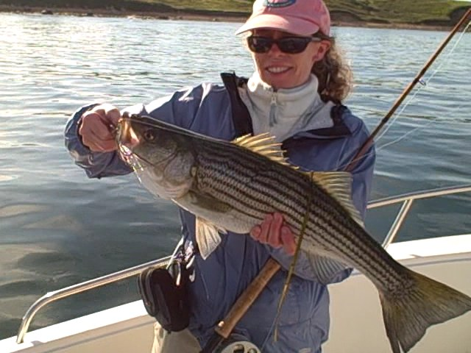
Suzanne 6.17.09
June 6, 2009
So the fishing has been pretty steady so far, and with fathers Day not far off it should only get better. Historically the week of Fathers Day is nuts, particularly on the west side with epic nights off the shore South of Charleston Beach. Customers in the shop today reporting bluefish caught at Clayhead and the charter boats have picked them up as well. There have been bass in the 20-30lb range caught trolling and with eels.... an occasional large keeper from the shore. The larger stick baits and needlefish are what surf casters are using. On the fly, I've had most luck with an all white deceiver... also sandeel patterns. The video link below is some of a morning at SW a few days ago - it's mediocre video but fun nonetheless. The tide was a ripping ebb and let me just say the dogfish were everywhere but the bass where also there with them.... good thing they don't hit a fly very often! The dogfish were spread thick from Graces Cove to SW Pt and wreaked havoc on the guys fishing bait. The North Light (AKA the Rip) also has been fished successfully the past week - tides worked when the sun is low on either horizon are the best times. Good friend and former guide 'Moose' had an epic night on the 6th... epic, as in 1/16 visibility and more fish than you can imagine an no one else around! Squid flies where the ticket (at the rip it usually is) with the largest at the mid 20# range. Matt King on the Hula Girl also had very good luck at the rip earlier in the day limiting out within the an hour on the troll with umbrellas. We should have a worm hatch soon in the inner ponds - this is always fun to watch and a challenge to fish.
http://www.youtube.com/watch?v=fvX_uhQEBSE
MAY 23, 2009
Stripers arrived a little over two weeks ago right as the shad was blooming. Rick Hall was once again the first to land a keeper bass on the Island - on May 4th I believe. But most of the local shore guys, Gary Censorio, Jamie Johnson, and Ed McGovern followed suit shortly after. Plenty of bait around - sandeels and baby bunker. 7"-9" soft plastics in a variety of colors have been working. Dark patterns at night for fly fishing have been best. There has been some good boat action along the SW Pt and North Light and I expect the south side to light up soon. Keepers are around with lots of schoolies. No Blues yet.

